Tune a guitar to itself

1. Tuning the guitar to itself. First you'll need a reference such as a tuning fork, piano or guitar. Once you have one of the strings tuned properly, you only need to fret to match the other strings as follows:
Low E string ( 6th string) at 5th fret matches open A string
A string at 5th fret matches the open D string
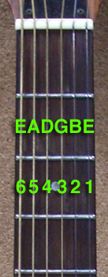
D string at 5th fret matches the open G string
G string at 4th fret matches the open B string
B string at 5th fret matches the open high E string
